Working through your wish lists

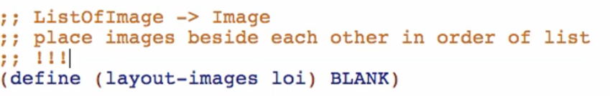

layout-images Function

Examples:

Base case empty: (needed here because layout-images is NOT a function composition problem anymore. It only does 1 task!



Other cases: (at least 2 long)

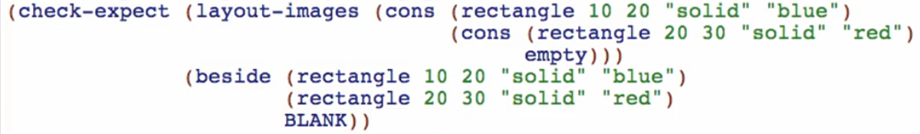

Template:

Copy from data definition, rename functions and natural recursions

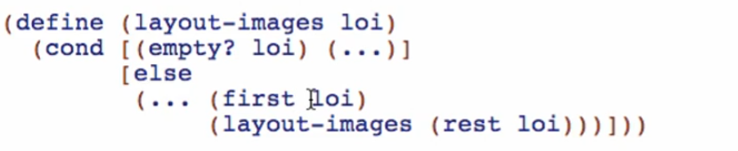

Code Body:

Base case:



Other cases: (based on your examples)

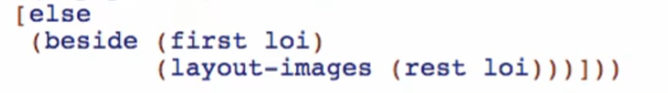

Test and debug:

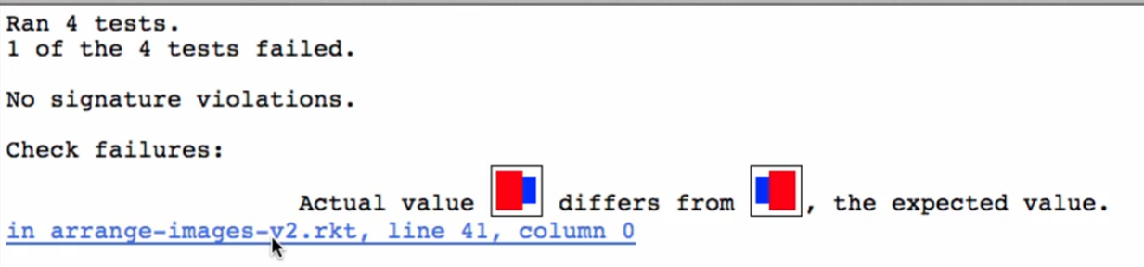

* Check if it is a test on **layout-images**

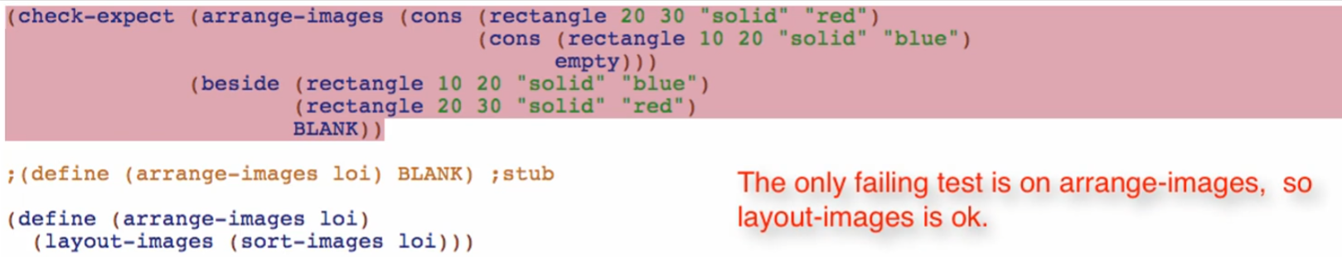

This is a test for SORTING of the images!

* If it is not, then you are done with your layout-images function

Overview:

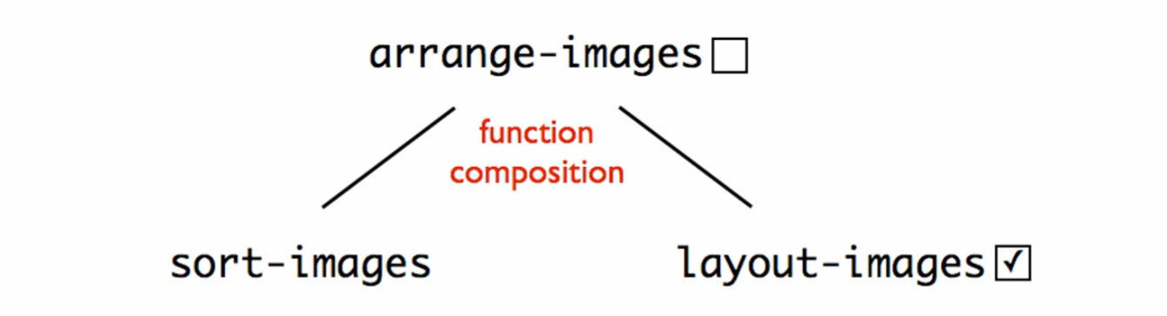

* layout-images Function is completely DONE